Request: update FG date Time and remarks by SO/Line

WMS:

New screen:

[OFI] -> Update FG Date

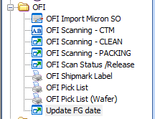

Button **[Update Details]** to update the selected FG date time.

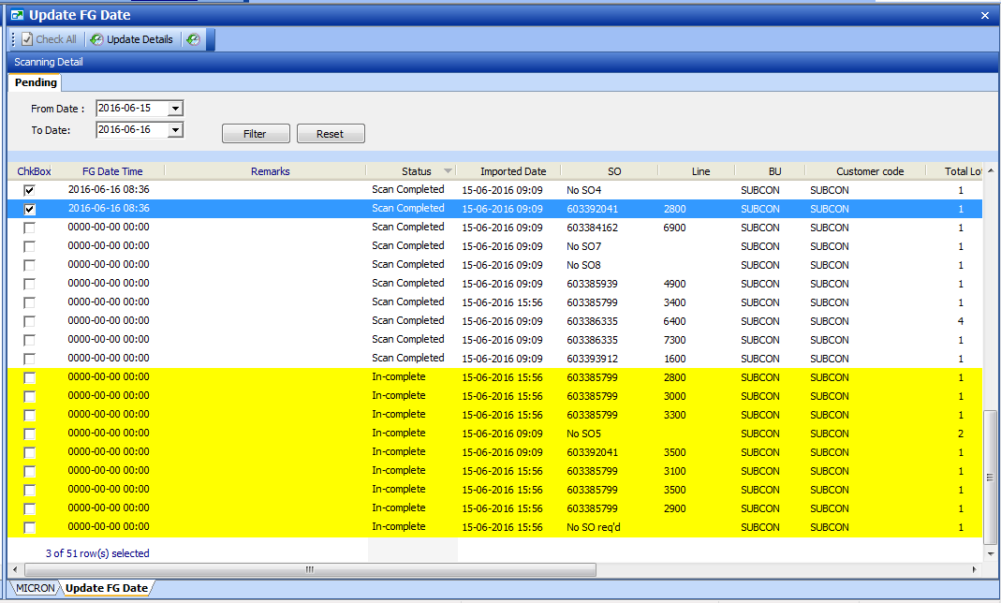

Button **[Filter]** allow user to filter outstanding list by imported date range.

Steps:

1. Select record to update by ‘tick’ on the “ChkBox” field.
2. System will auto set the FG date time as current time, date time is allow to amend.
3. User to input remarks, ( optional field)
4. Click [Update Details] button to save the FG date time.

SO Summary report:

Display the updated FG date / time and remarks

